Supporting information

Precise lysosome pH indicator based on self-decomposable nanoparticles

Cui Pang, ^{2#} Chaojun Song, ^{3#} Yize Li, ^{2#} Qiaofeng Wang, ¹ Xiaosheng Zhu, ² Jianwei Wu, ² Yi Tian, ² Hao Fan, ¹ Jinwei Hu, ¹ Chen Li, ¹ Baolong Wang, ¹ Li Fan,^{1*} Wenchao Liu b ^{2*}

¹ Department of pharmaceutical analysis, School of Pharmacy, The Fourth military medical university, Xi’an, Shaanxi, China, 710032
² Department of Oncology, Xijing Hospital, The Fourth Military Medical University, Xi’an, 710032, China
³ School of Life Science, Northwestern Polytechnic University, 127th Youyi west road, Xi’an, Shaanxi, China, 710072
* Correspondence and requests for materials should be addressed to Fan Li, email: xxfanny@fmmu.edu.cn or Wenchao Liu, email: liuch@fmmu.edu.cn
#These authors contributed equally to this work.

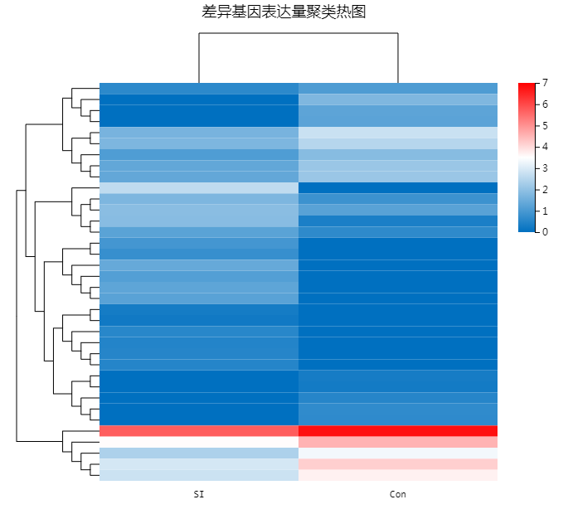
Figure S1 Cluster heat map of differential gene expression, the scale bar from blue to red represents the quantity of gene differences increase (From 0 to 7 fold).

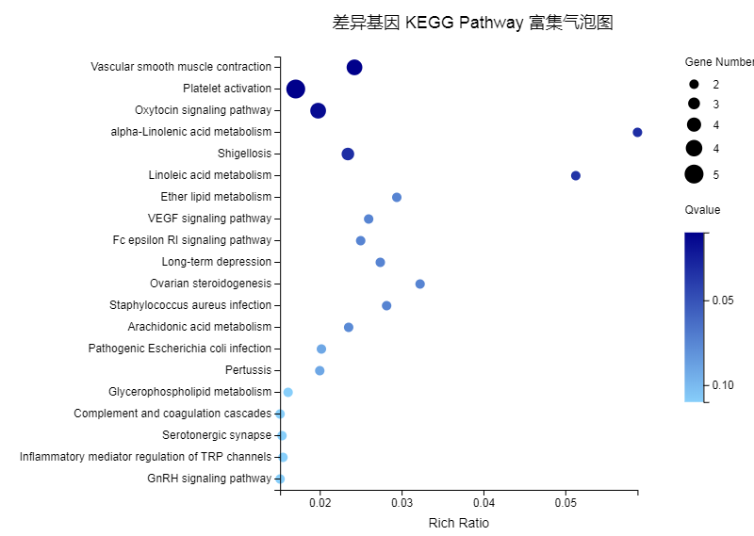
Figure S2 Differential genes KEGG Pathway enrichment bubble map of BPSi fed cells.

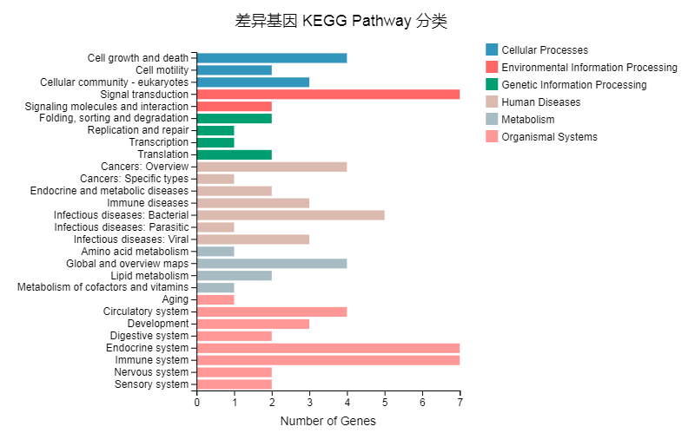
Figure S3 Differential genes KEGG Pathway classification.
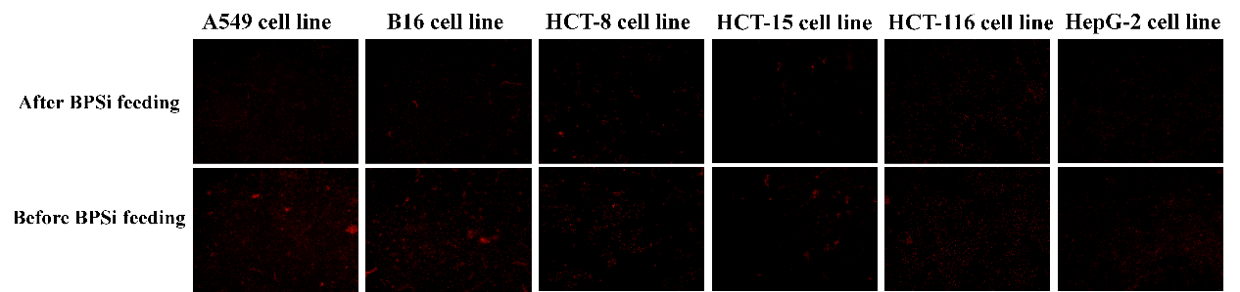
Figure S4 Intracellular pH measurements in 6 different cell line before and after BPSi nanoparticles feeding.

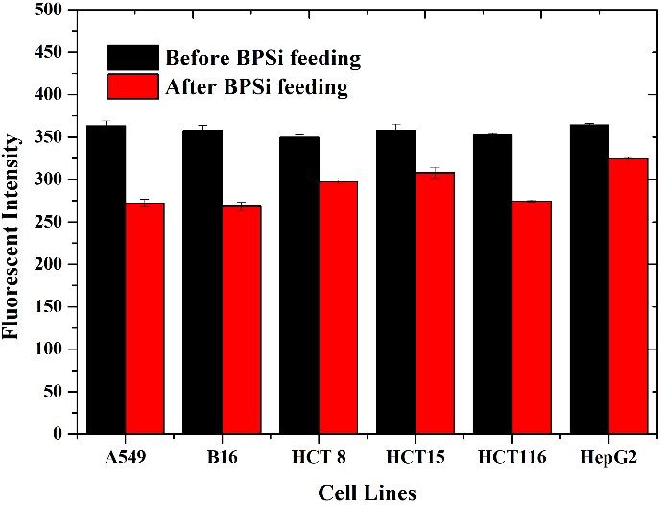
Figure S5 Drug Quantitative analysis of fluorescent intensity in 6 different cell line before and after BPSi feeding. All experiments were triple repeated, and the data were shown as mean ± S.D..

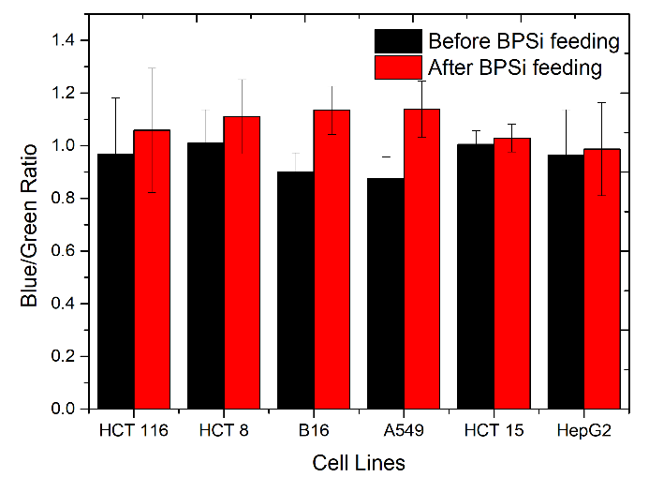
Figure S6 Drug quantitative analysis of blue and green fluorescent intensity ratio in 6 different cell line before and after BPSi feeding. All experiments were triple repeated, and the data were shown as mean ± S.D..

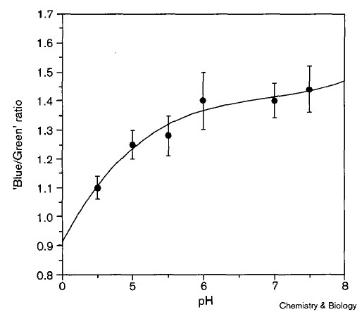
Figure S7 The correlation between the Blue/Green Ratio and the pH values at the pH range from 0 to 8. (Diwu Z, Chen C-S, Zhang C, Klaubert DH, Haugland RP (1999) A novel acidotropic pH indicator and its potential application in labeling acidic organelles of live cells. Chem Biol 6:411–418.)

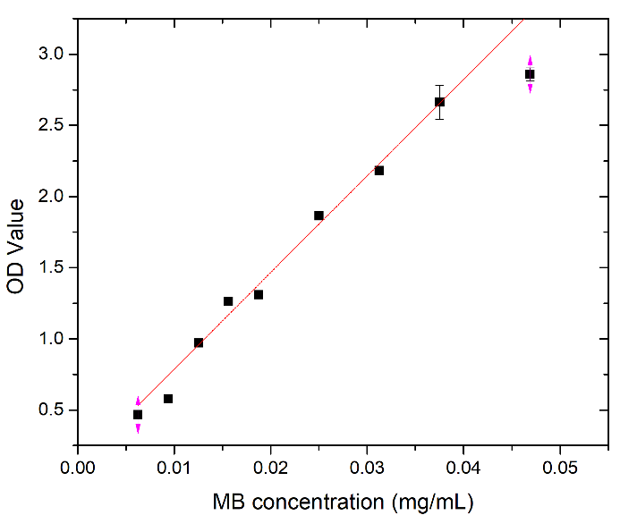
Figure S8 Standard curve of MB solution at series MB concentration.
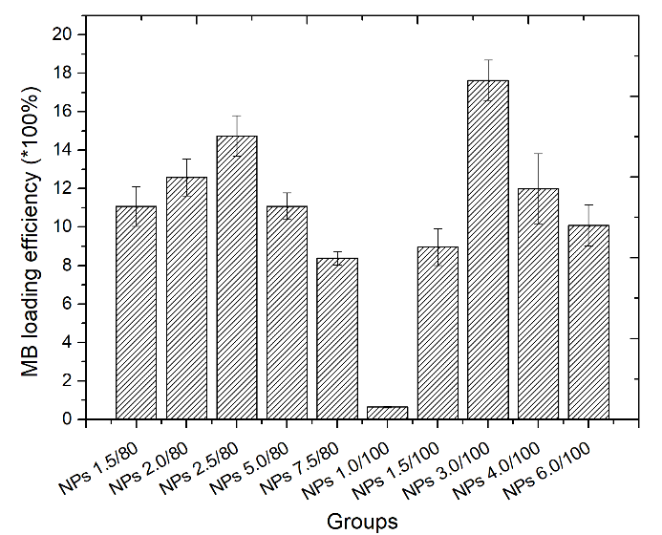
Figure S9 MB loading efficiency of 10 self-decomposable nanoparticles with specific parameters. All experiments were triple repeated, and the data were shown as mean ± S.D..
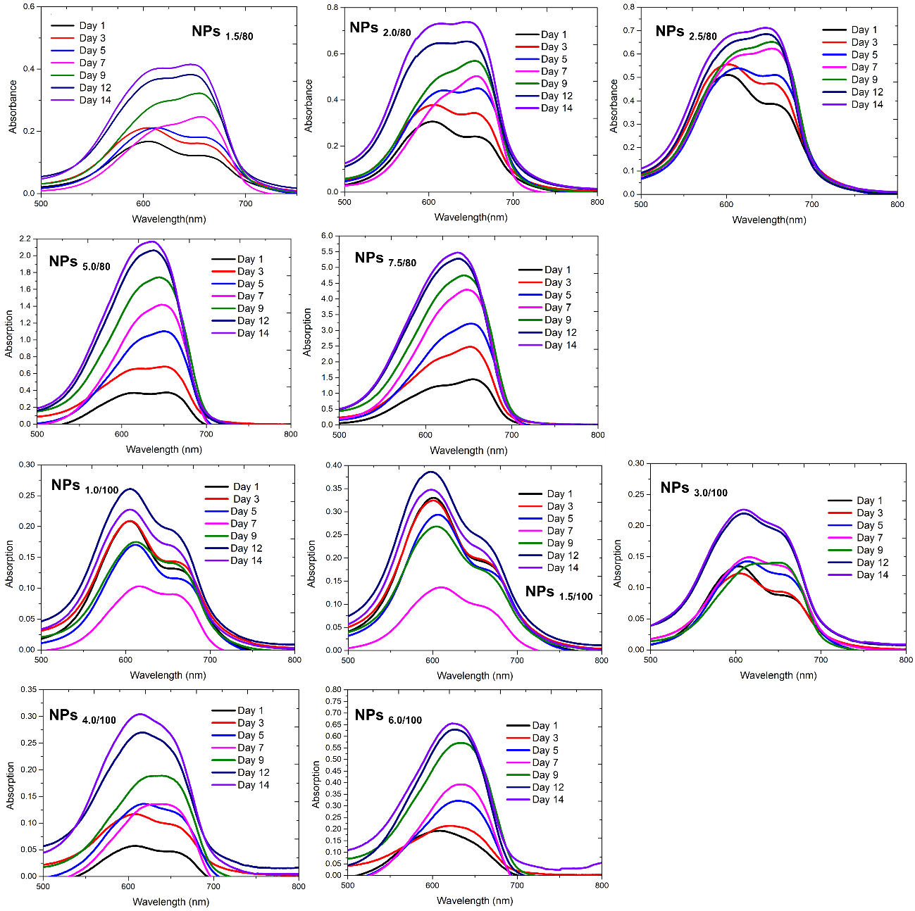
Figure S10 Absorption of MB release from 10 self-decomposable nanoparticles with specific parameters were recorded with the spectrum range from 500-800 nm during 14 days immersed in distilled water.
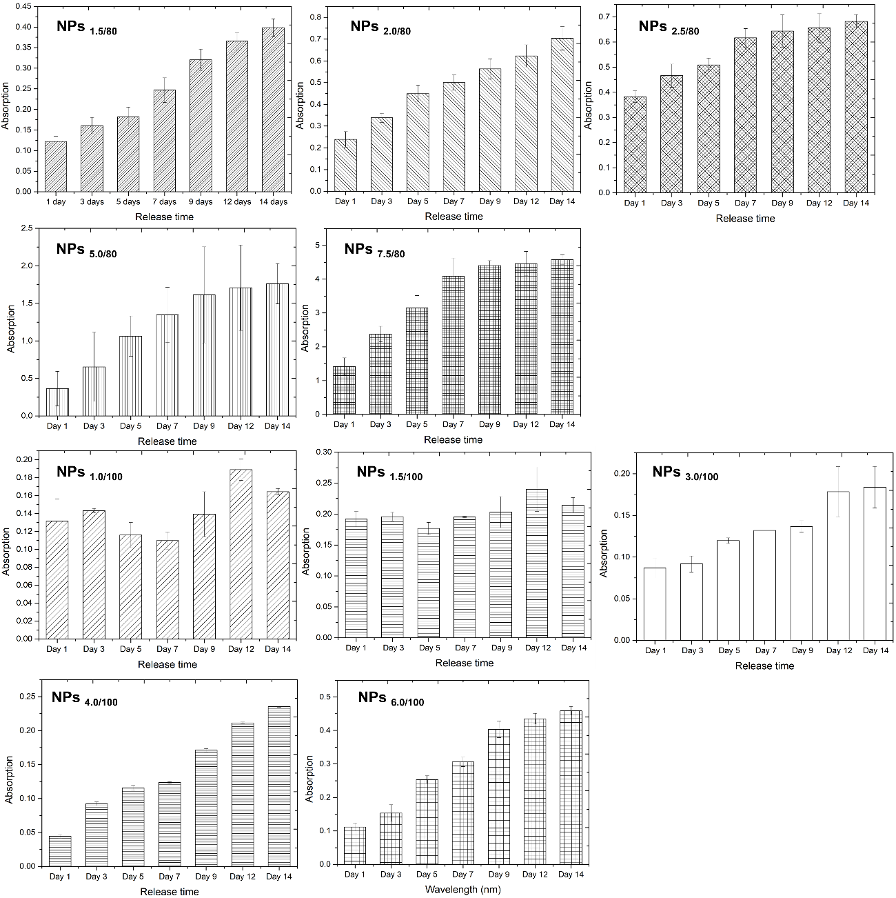
Figure S11 Peak value at 660 nm in specific time duration was selected in 10 series of nanoparticles to give more direct evidence on MB release profiles. All experiments were triple repeated, and the data were shown as mean ± S.D..
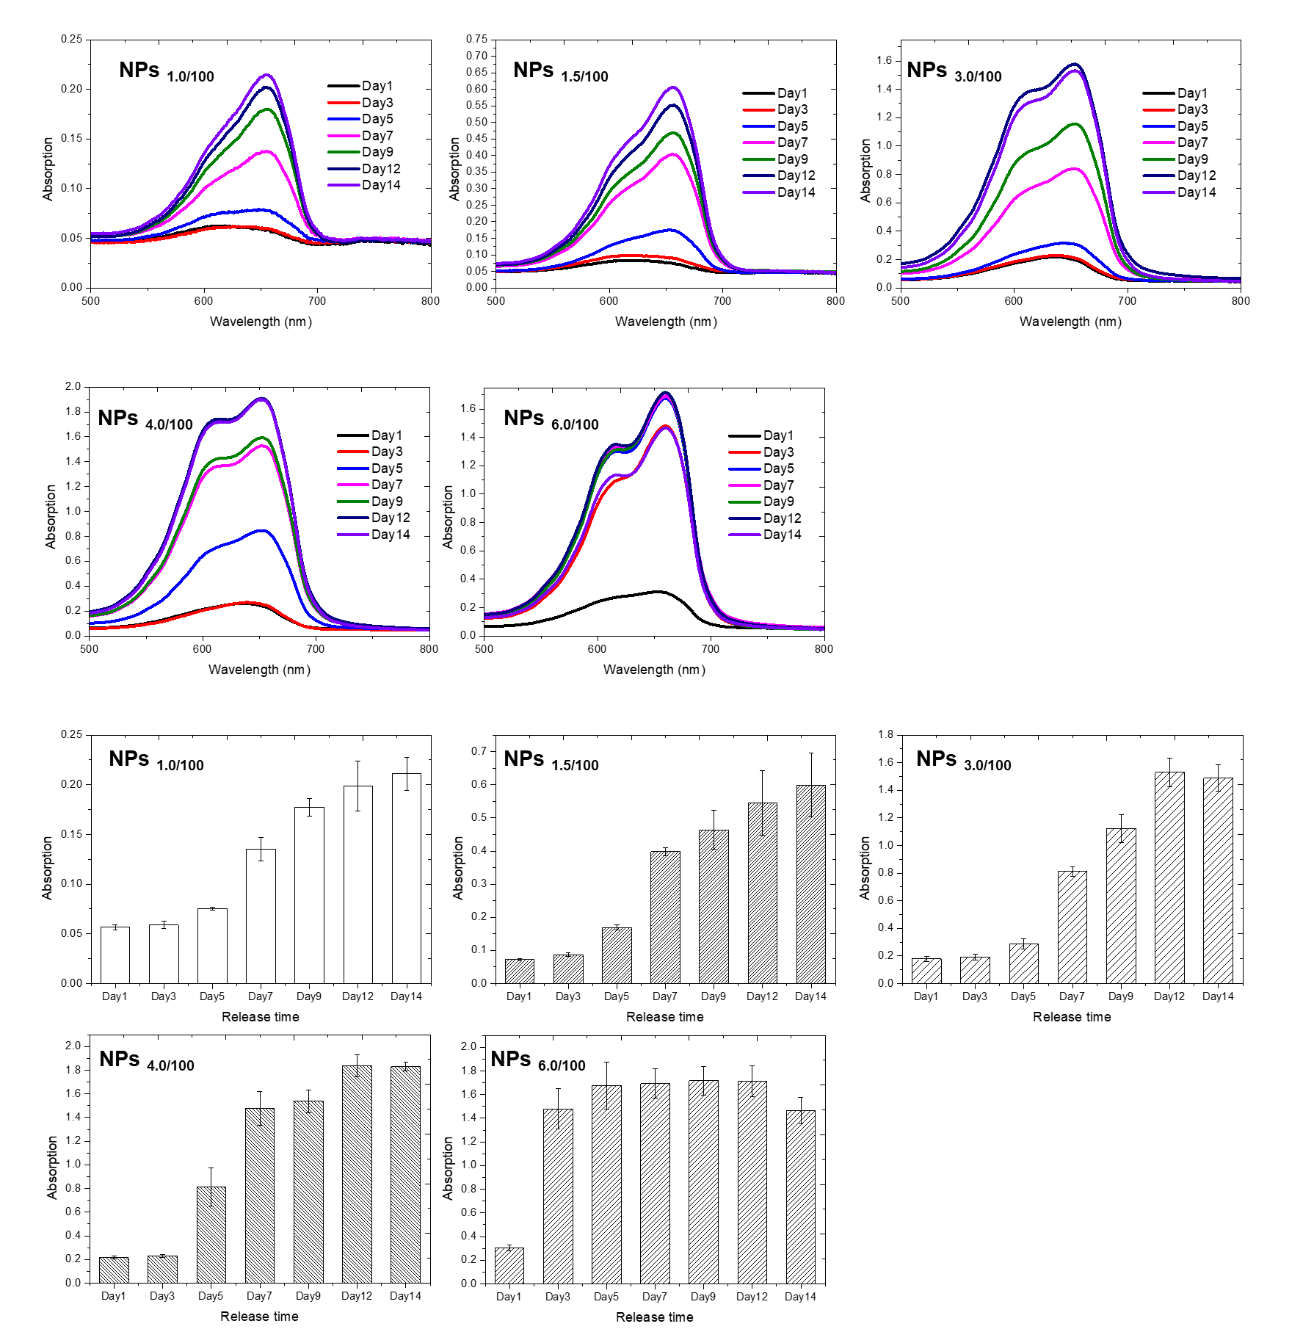
Figure S12 MB release profile of 5 self-decomposable nanoparticles in pH 4 buffer solution after specific duration. UV-Vis spectrums and MB release profiles of 5 series self-decomposable nanoparticles with TEOS adding amount of 100 μL. All experiments were triple repeated, and the data were shown as mean ± S.D..
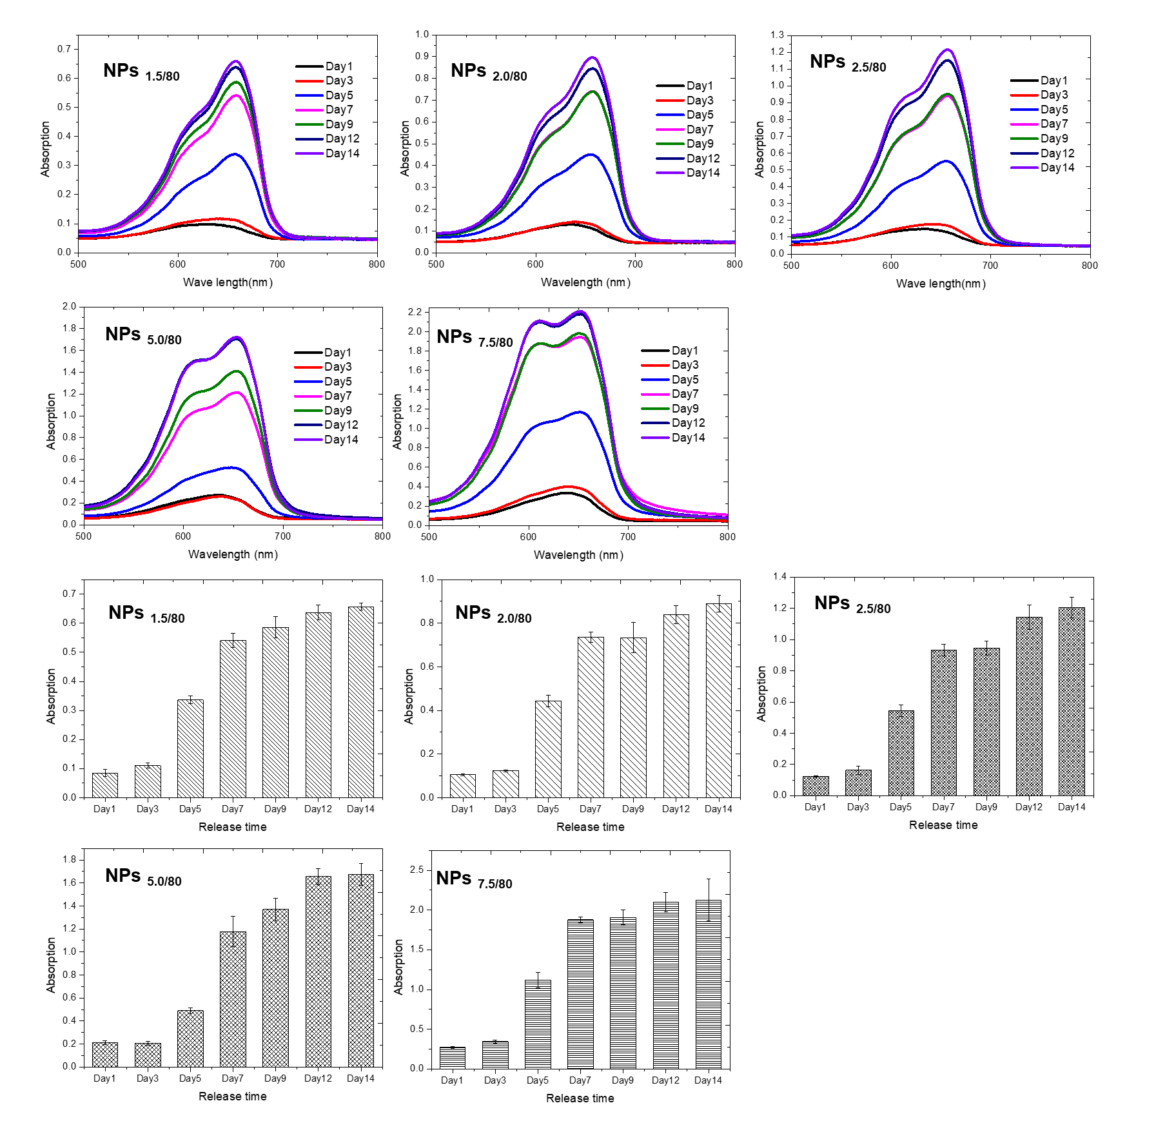
Figure S13 MB release profile of 5 self-decomposable nanoparticles in pH 4 buffer solution as a function of release duration. UV-Vis spectrums and MB release profiles of 5 series self-decomposable nanoparticles with TEOS adding amount of 80 μL. All experiments were triple repeated, and the data were shown as mean ± S.D..
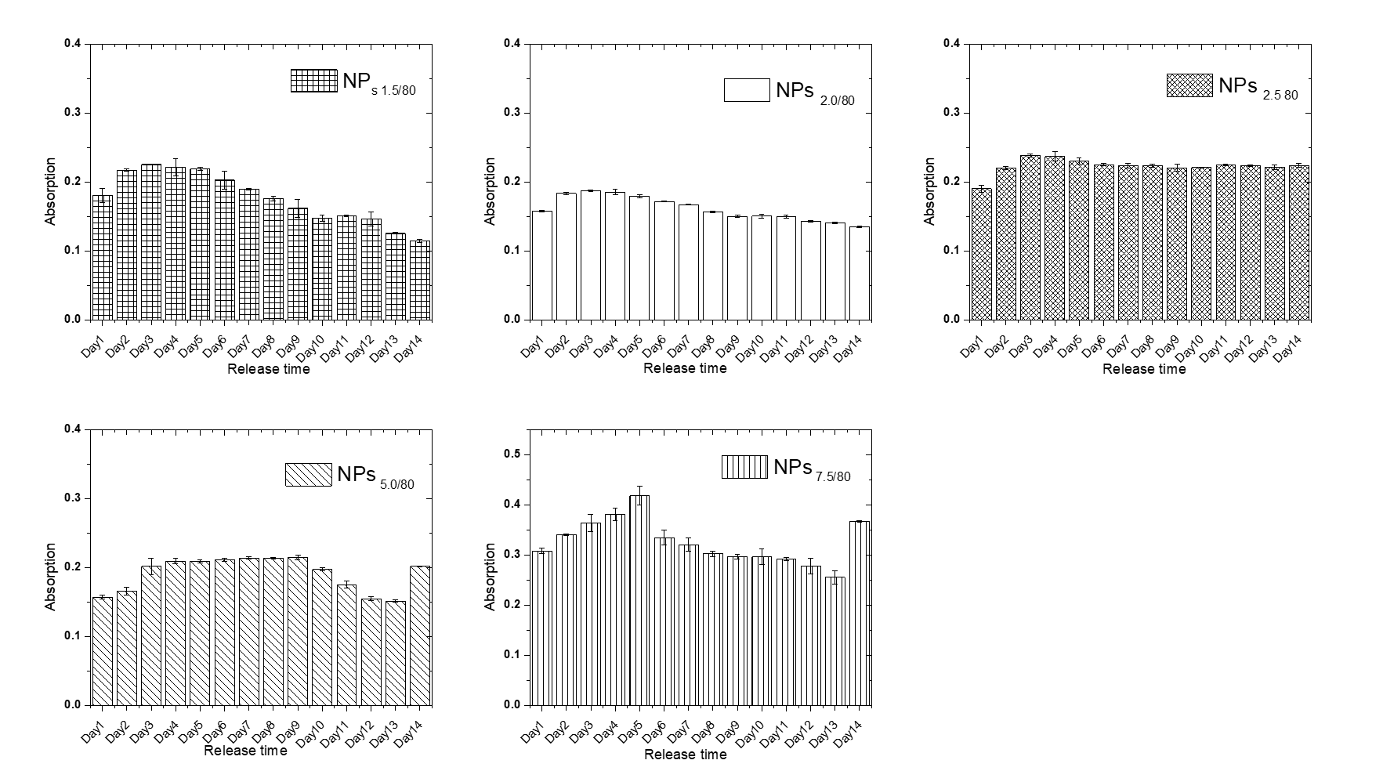
Figure S14 MB release profile by UV-Vis spectrums of 5 self-decomposable nanoparticles with TEOS adding amount of 80 μL in pH 6.86 buffer solution as a function of release duration. All experiments were triple repeated, and the data were shown as mean ± S.D..
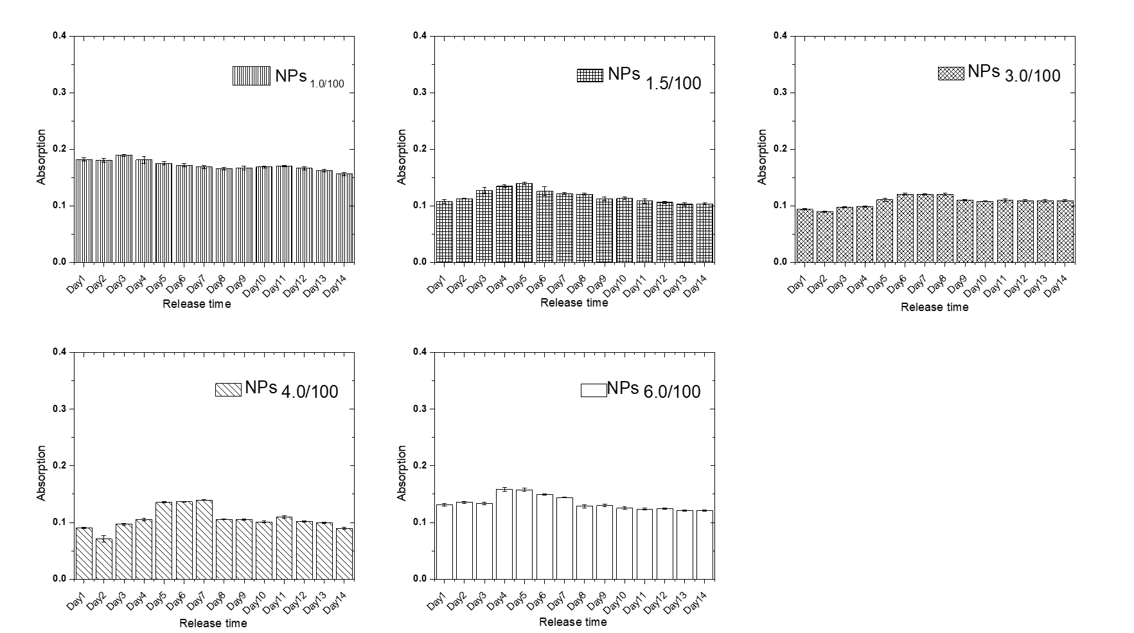
Figure S15 MB release profile by UV-Vis spectrums of 5 self-decomposable nanoparticles with TEOS adding amount of 100 μL in pH 6.86 buffer solution as a function of release duration. All experiments were triplicated, and the data were shown as mean ± S.D..
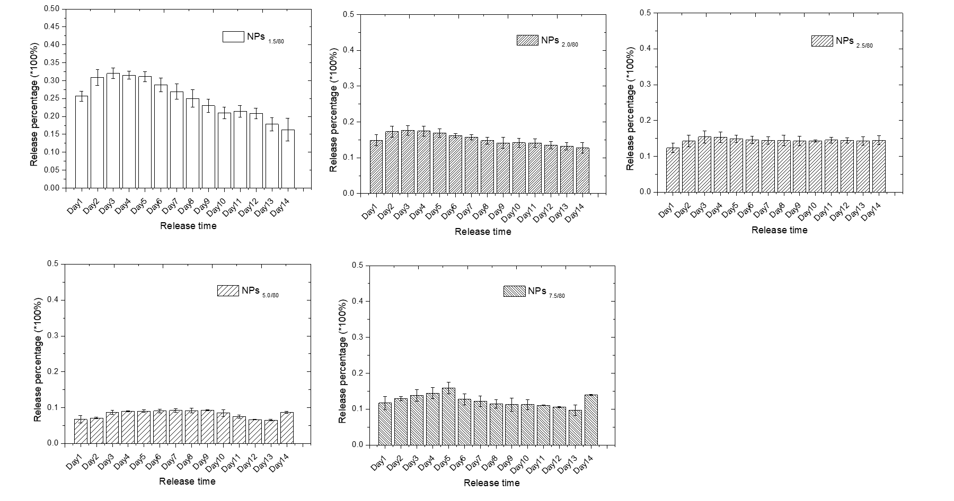
Figure S16 MB release percentage profiles of 5 self-decomposable nanoparticles with TEOS adding amount of 80 μL in pH 6.86 buffer solution as a function of release time duration. All experiments were triplicated, and the data were shown as mean ± S.D..
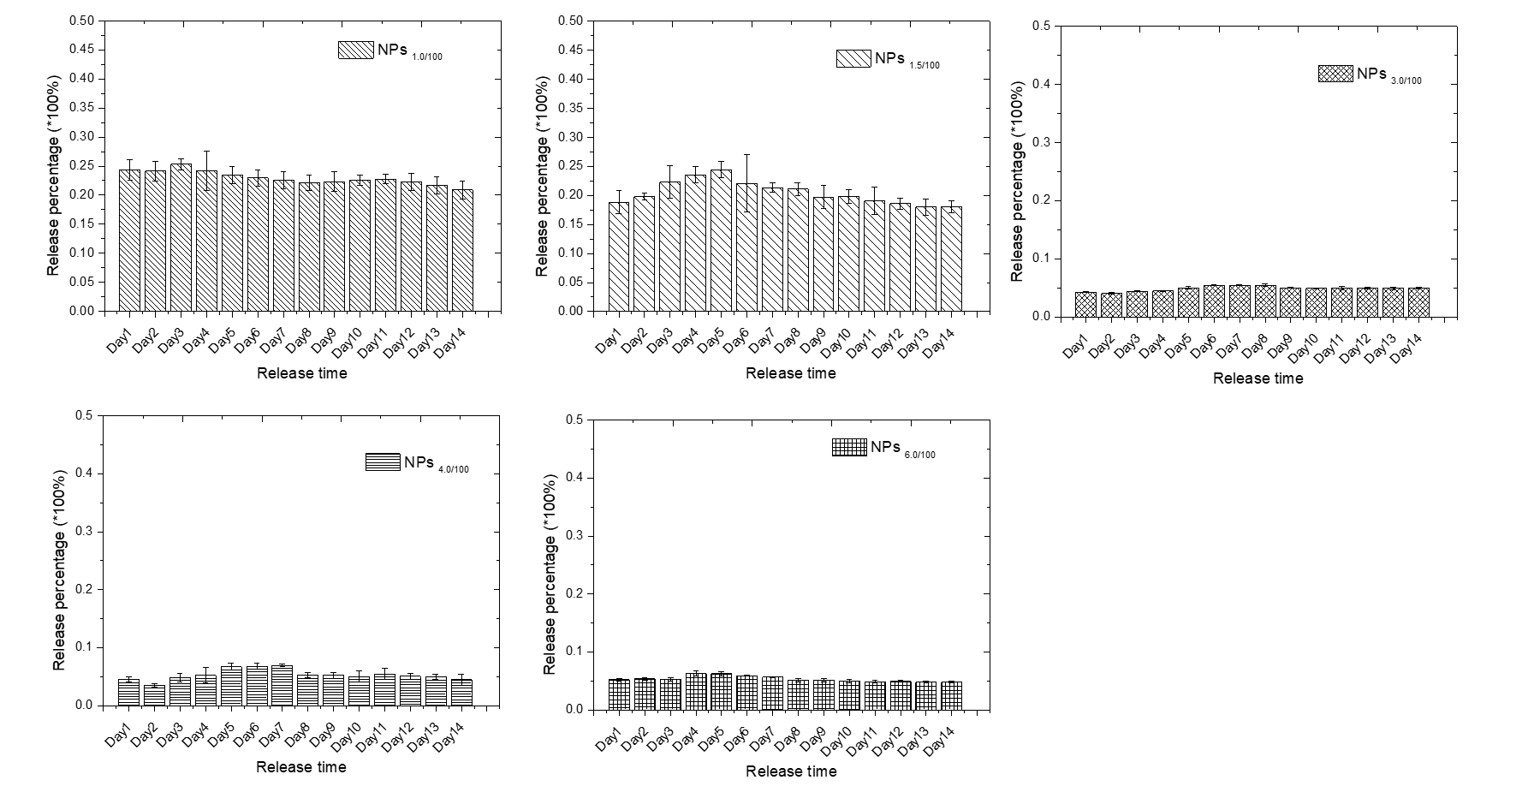
Figure S17 MB release percentage profiles of 5 self-decomposable nanoparticles with TEOS adding amount of 100 μL in pH 6.86 buffer solution as a function of release time duration. All experiments were triplicated, and the data were shown as mean ± S.D..
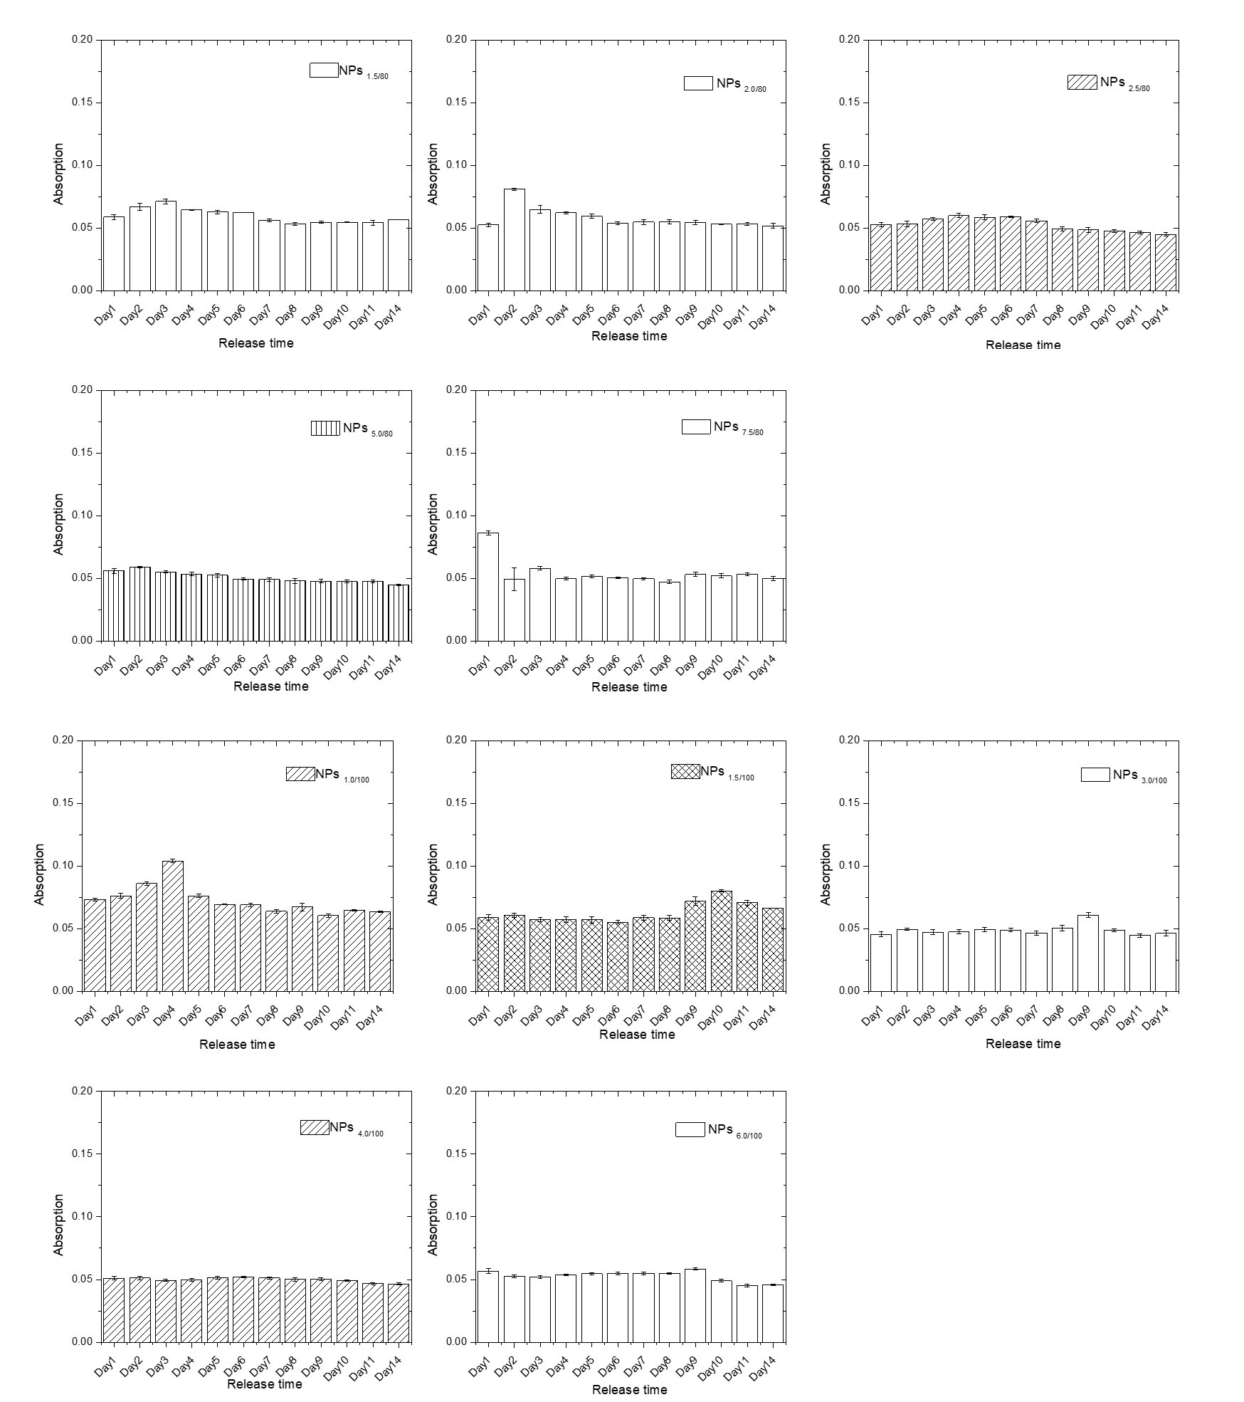
Figure S18 MB release profile by UV-Vis spectrums of 10 self-decomposable nanoparticles with TEOS adding amount of 80 μL and 100 μL in pH 9.18 buffer solution as a function of release duration. All experiments were triplicated, and the data were shown as mean ± S.D..
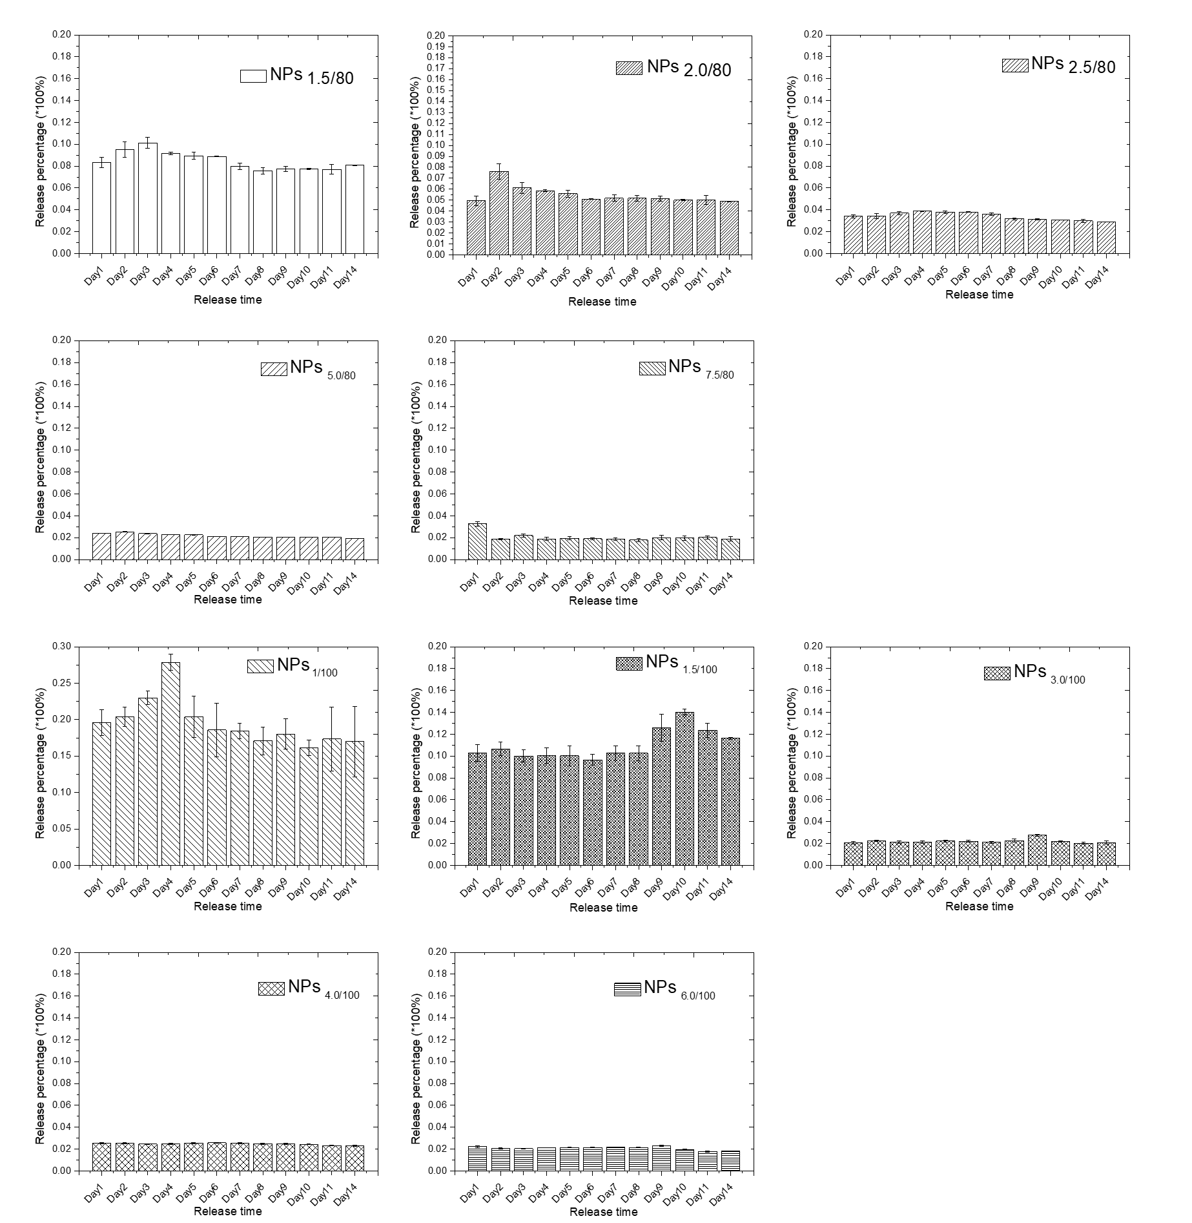
Figure S19 MB release percentage profiles of 10 self-decomposable nanoparticles with TEOS adding amount of 80 μL and 100 μL in pH 9.18 buffer solution as a function of release time duration. All experiments were triplicated, and the data were shown as mean ± S.D..
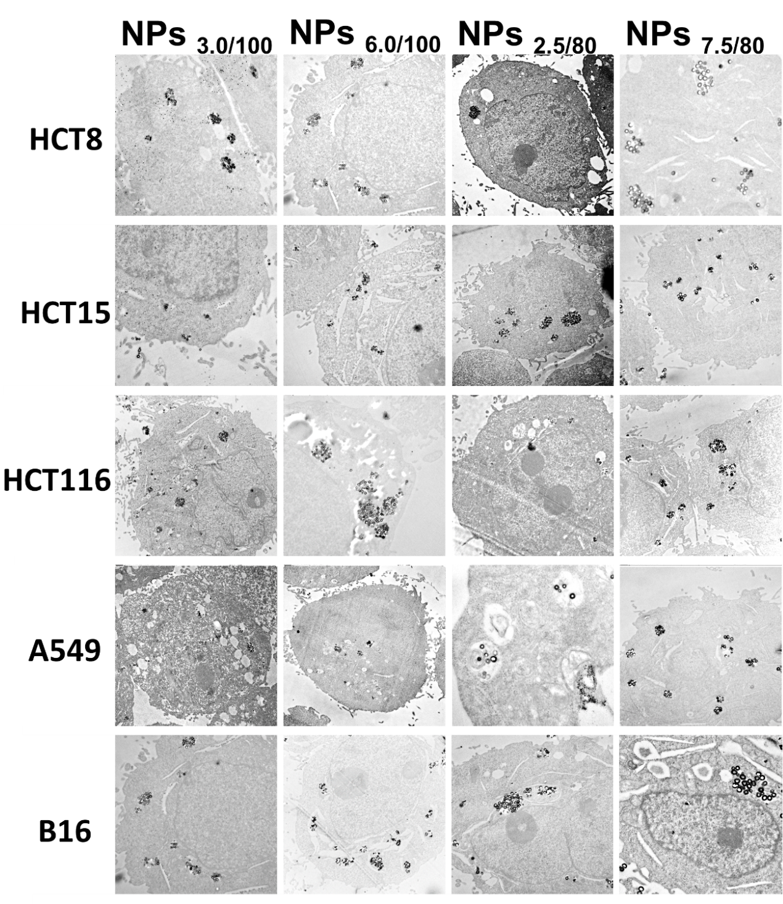
Figure S20 The colocalization of the nanoparticle in the endo/lysosomes by cell TEM study after 24 hrs incubation with the randomly chosen of nanoparticles of both 80 μL and 100 μL TEOS amount groups in HCT8, HCT15, HCT116, A549 and B16 cell lines.
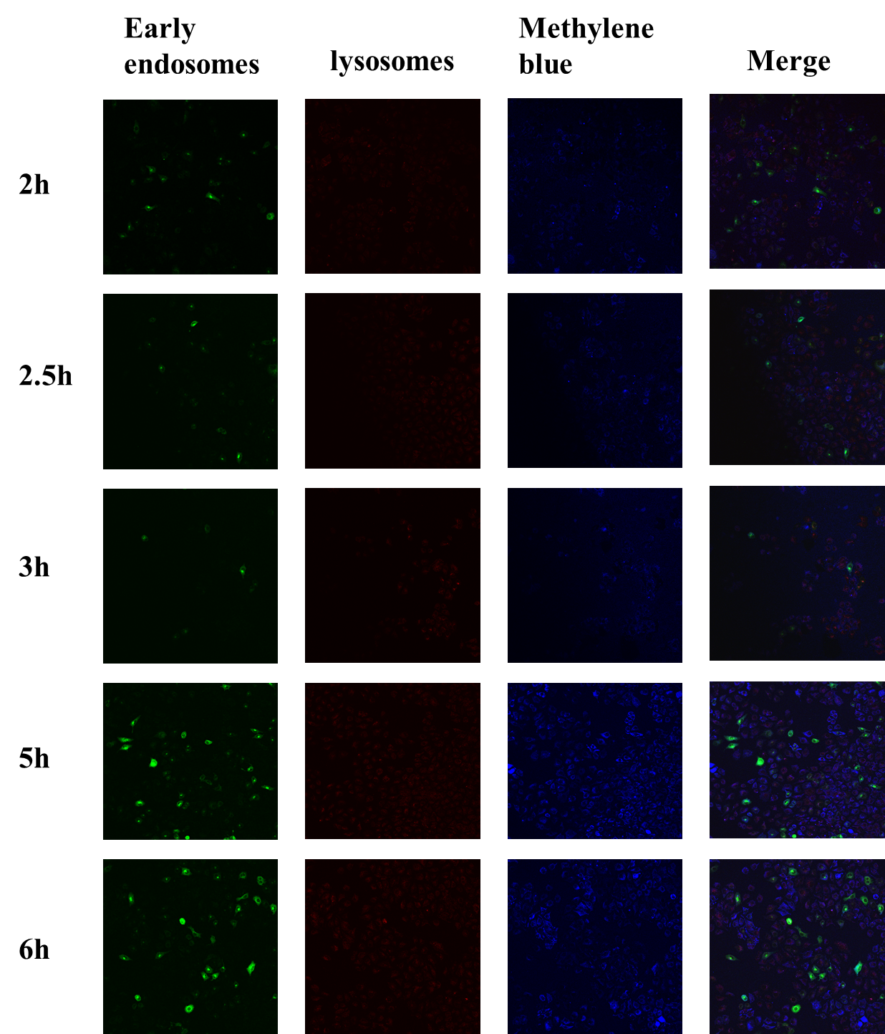
Figure S21 The colocalization of the nanoparticle in the early endosomes or lysosomes by cell confocal study after several time point incubation with the NPs _{6.0/100} in HepG-2 cell lines.
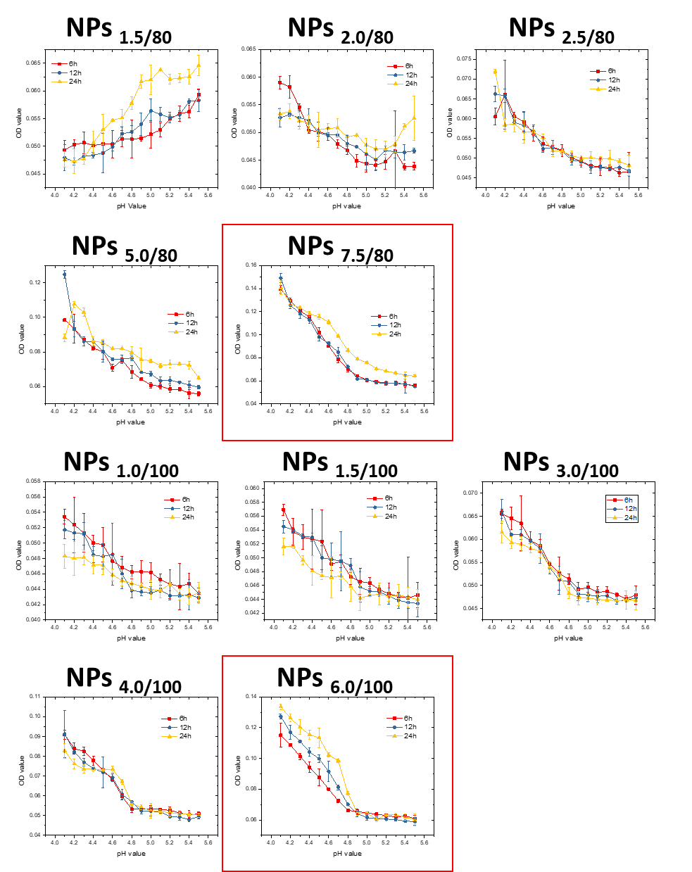
Figure S22 MB release as a function of pH values in 10 series self-decomposable nanoparticles after specific incubation duration, 6 hrs, 12 hrs and 24 hrs. All experiments were carried out triplicated, and the data were shown as mean ± S.D..
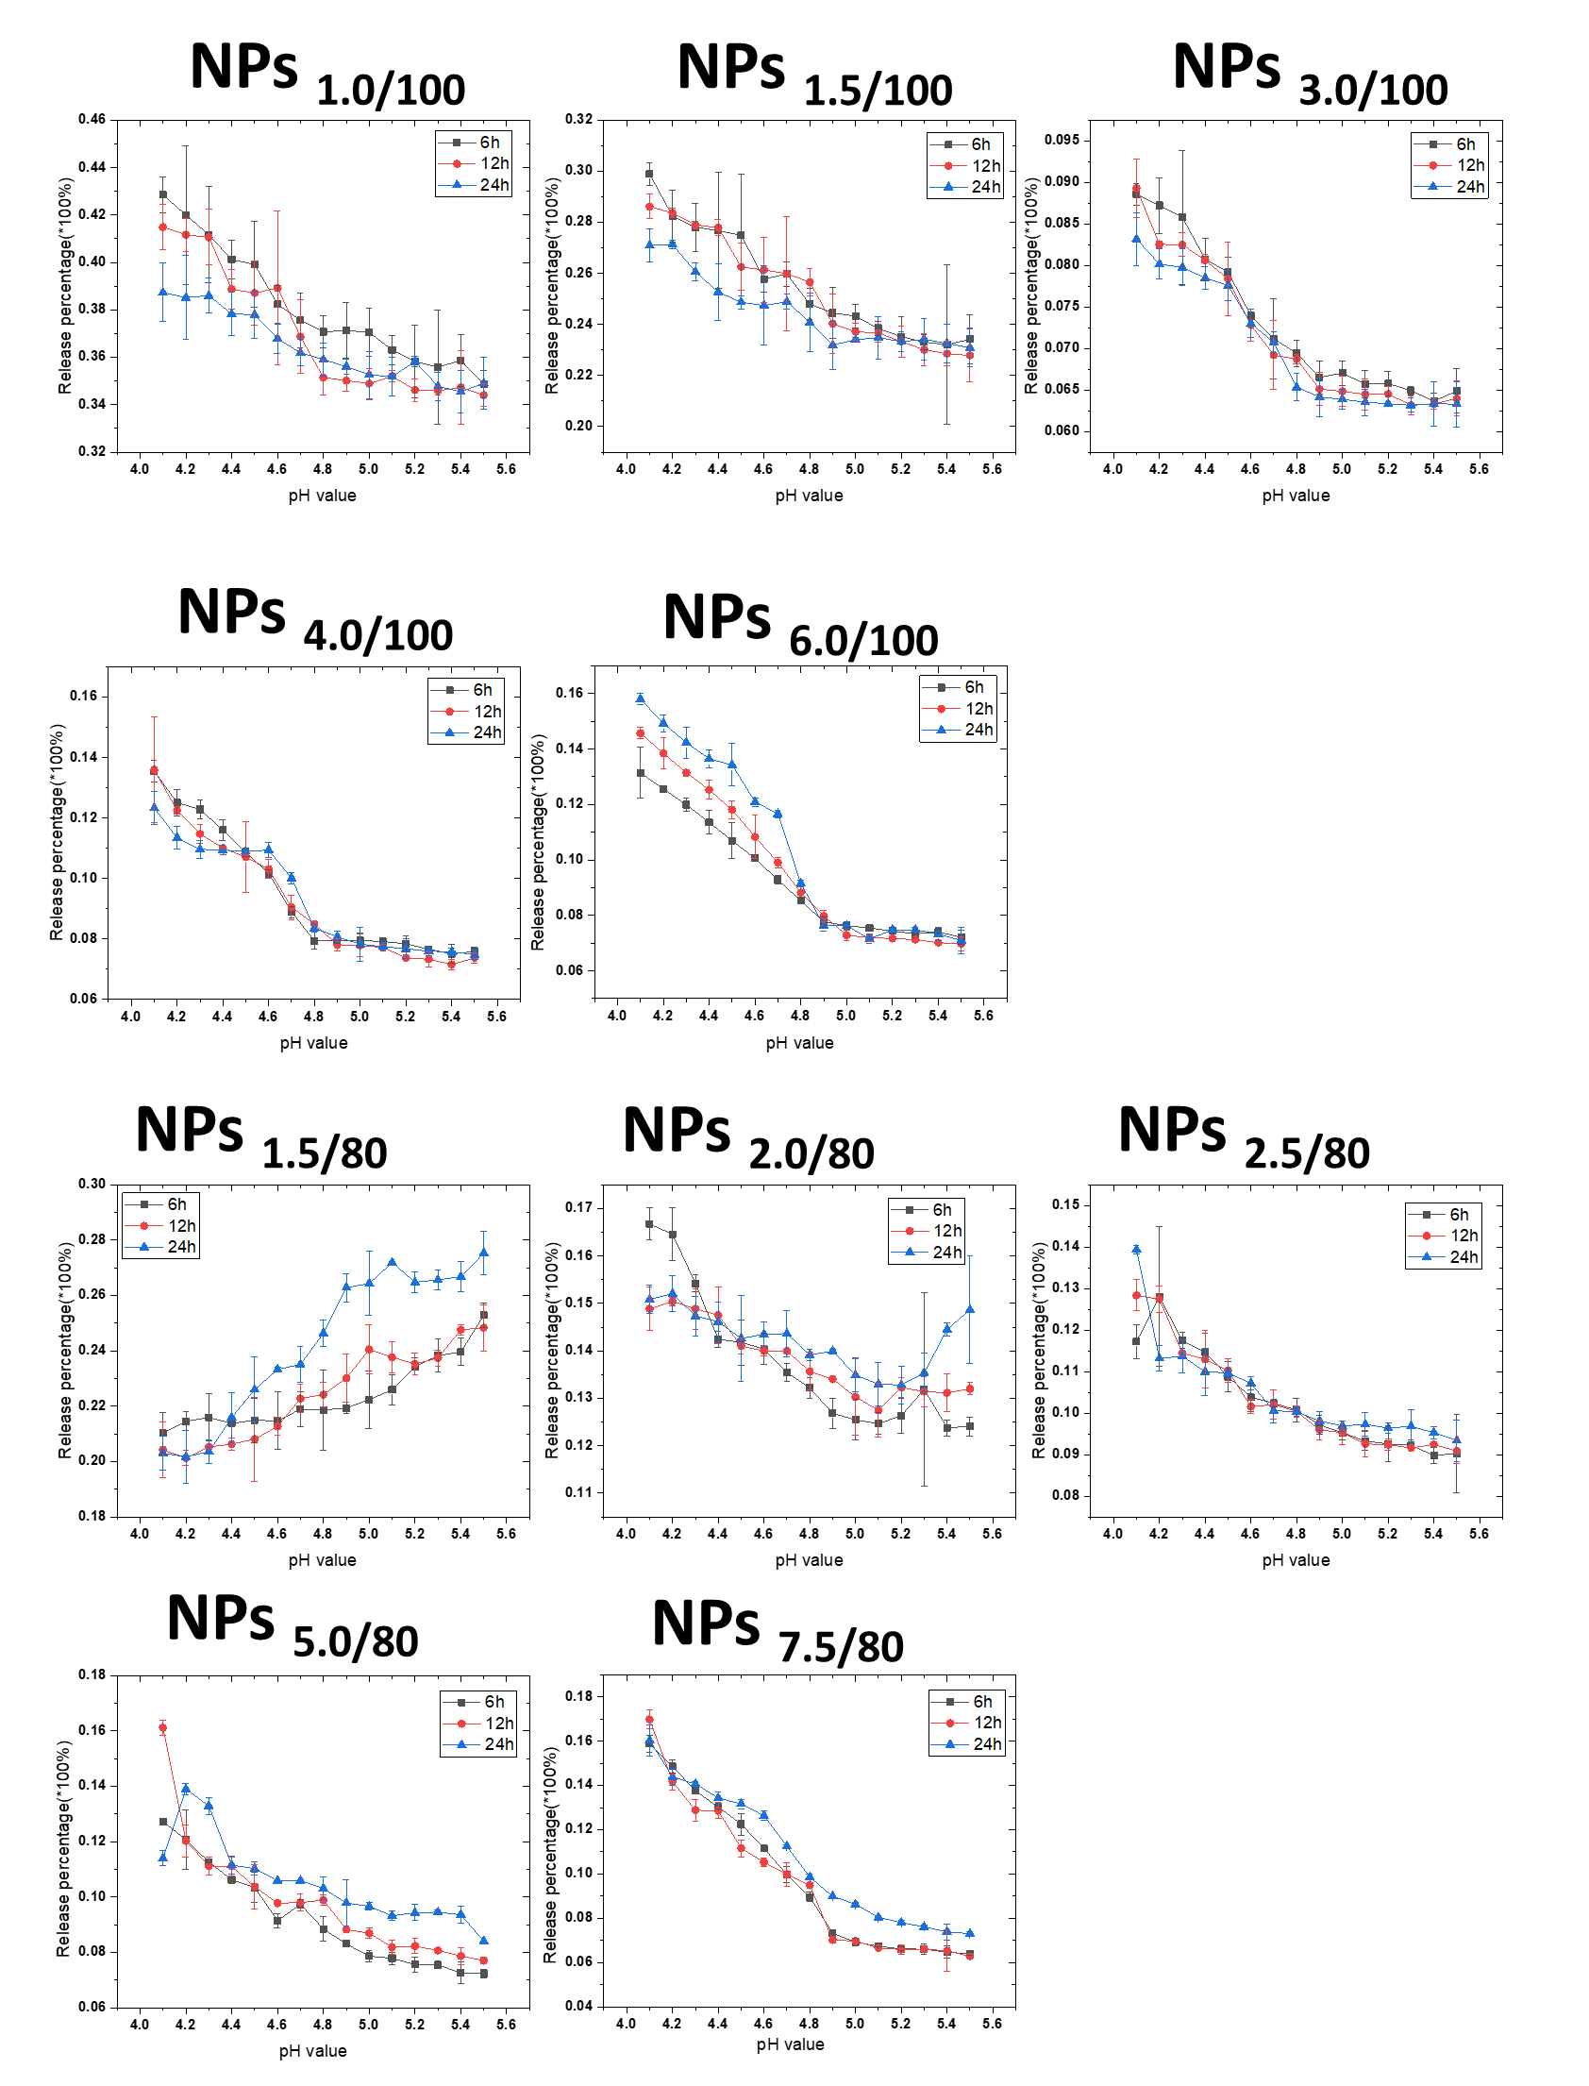
Figure S23 MB release percentage as a function of pH values in 10 series self-decomposable nanoparticles as a function of pH values, 6 hrs, 12 hrs and 24 hrs. All experiments were carried out triplicated, and the data were shown as mean ± S.D..
Figure S24 MB release amount in HepG-2 cells after incubation different times. All experiments were carried out triplicated, and the data were shown as mean ± S.D..

Table S1 Residual Sum of Squares and Pearson's related coefficient at 6 hrs release duration of 10 nanoparticle systems linear fitting
 | NPs _{1.5/80} | NPs _{2.0/80} | NPs _{2.5/80} | NPs _{5.0/80} | NPs _{7.5/80} | NPs _{1.0/100} | NPs _{1.5/100} | NPs _{3.0/100} | NPs _{4.0/100} | NPs _{6.0/100}
Residual Sum of Squares | 0.09948 | 0.03363 | 0.07444 | 0.02647 | 0.01776 | 0.00595 | 0.03147 | 0.00938 | 0.00973 | 0.01471
Pearson's r | 0.82369 | -0.95903 | -0.90264 | -0.96792 | -0.98960 | -0.9827 | -0.9602 | -0.9885 | -0.98833 | -0.99223
Table S2 Residual Sum of Squares and Pearson's related coefficient at 12 hrs release duration of 10 nanoparticle systems linear fitting
 | NPs _{1.5/80} | NPs _{2.0/80} | NPs _{2.5/80} | NPs _{5.0/80} | NPs _{7.5/80} | NPs _{1.0/100} | NPs _{1.5/100} | NPs _{3.0/100} | NPs _{4.0/100} | NPs _{6.0/100}
Residual Sum of Squares | 0.06116 | 0.04536 | 0.0339 | 0.13642 | 0.05542 | 0.03859 | 0.02997 | 0.01969 | 0.02581 | 0.0148
Pearson's r | 0.91893 | -0.94261 | -0.9587 | -0.82146 | -0.9316 | -0.95015 | -0.96268 | -0.97613 | -0.96874 | -0.98198

Table S3. Primers used for quantitative RT-PCR
Gene Name | Forward primer | Reverse primer
MFN1 | TGGCTAAGAAGGCGATTACTGC | TCTCCGAGATAGCACCTCACC
MFN2 | CTCTCGATGCAACTCTATCGTC | TCCTGTACGTGTCTTCAAGGAA
OPA1 | TGTGAGGTCTGCCAGTCTTTA | TGTCCTTAATTGGGGTCGTTG
DRP1 | CTGCCTCAAATCGTCGTAGTG | GAGGTCTCCGGGTGACAATTC
TFEB | CCAGAAGCGAGAGCTCACAGAT | TGTGATTGTCTTTCTTCTGCCG
CTSA | CAGGCTTTGGTCTTCTCTCCA | TCACGCATTCCAGGTCTTTG
CTSB | AGTGGAGAATGGCACACCCTA | AAGAAGCCATTGTCACCCCA
CTSD | AACTGCTGGACATCGCTTGCT | CATTCTTCACGTAGGTGCTGGA
CTSF | ACAGAGGAGGAGTTCCGCACTA | GCTTGCTTCATCTTGTTGCCA
GNS | CCCATTTTGAGAGGTGCCAGT | TGACGTTACGGCCTTCTCCTT
TPP1 | GATCCCAGCTCTCCTCAATACG | GCCATTTTTGCACCGTGTG
MCOLN1 | TTGCTCTCTGCCAGCGGTACTA | GCAGTCAGTAACCACCATCGGA
LAMP1 | ACGTTACAGCGTCCAGCTCAT | TCTTTGGAGCTCGCATTGG
LAMP2 | GCACAGTGAGCACAAATGAGT | CAGTGGTGTGTATGGTGGGT
ATP6VOD2 | TCTCACCTATATGACGTGCAGT | GGTGGCACTTCCCCAGAATTT
ATP6V0E1 | CATTGTGATGAGCGTGTTCTGG | AACTCCCCGGTTAGGACCCTTA
ATP6V1H | GGAAGTGTCAGATGATCCCCA | CCGTTTGCCTCGTGGATAAT
CLCN7 | TGATCTCCACGTTCACCCTGA | TCTCCGAGTCAAACCTTCCGA
ACTIN | CTGTCCACCTTCCAGCAGATGT | CGCAACTAAGTCATAGTCCGCC

